Louisiana State Board of Medical Examiners
Cecilia A. Mouton, MD, Executive Director
P.O. Box 30250
New Orleans, LA 70190-0250
(street address: 630 Camp St., 70130)
(504) 568-6816 / Fax:(504) 568-5754
www.lsbme.louisiana.gov

Mississippi State Board of Medical Licensure
H. Vann Craig, MD, Executive Director
1867 Crane Ridge Drive, Suite 200B
Jackson, MS 39216
(601) 987-3079 / Fax:(601) 987-4159
www.msbml.state.ms.us

Texas Medical Board
Mari Robinson, JD, Executive Director
P.O. Box 2018
Austin, TX 78768-2018
(512) 305-7010/Fax: (512) 305-7008
Disciplinary Hotline (800) 248-4062
Consumer Complaint Hotline (800) 201-9353
www.tmb.state.tx.us

Arkansas State Medical Board
Peggy Pryor Cryer, Executive Secretary
1401 West Capitol Avenue, Suite 340
Little Rock, AR 72201
(501) 296-1802 / Fax:(501) 603-3555
www.armedicalboard.org

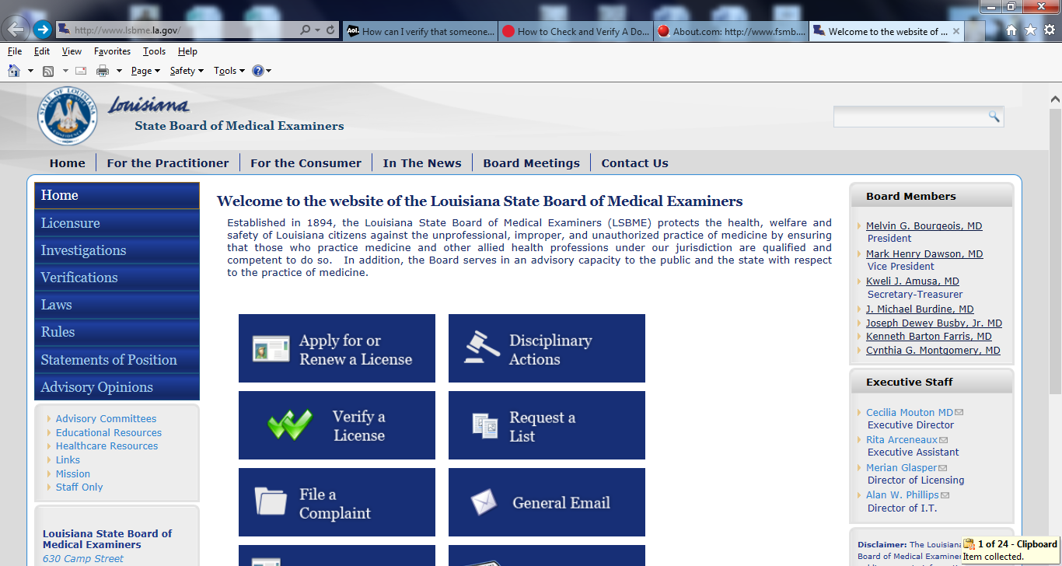

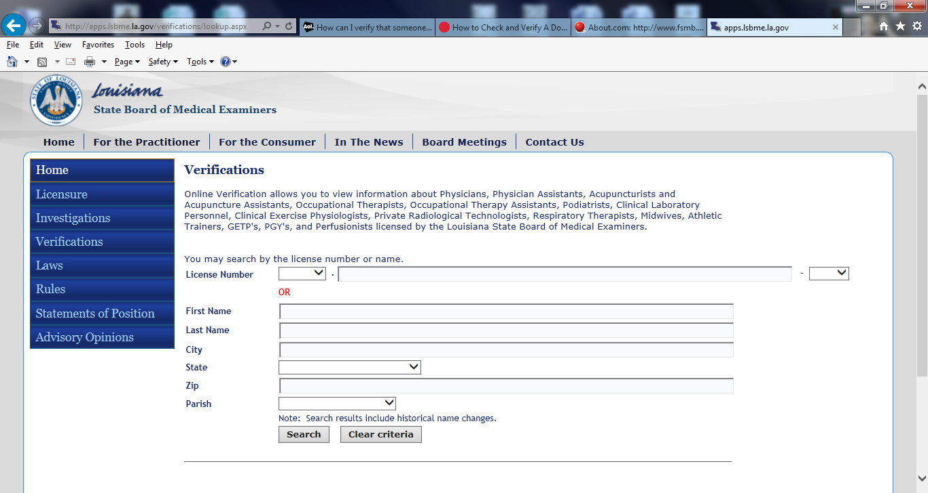

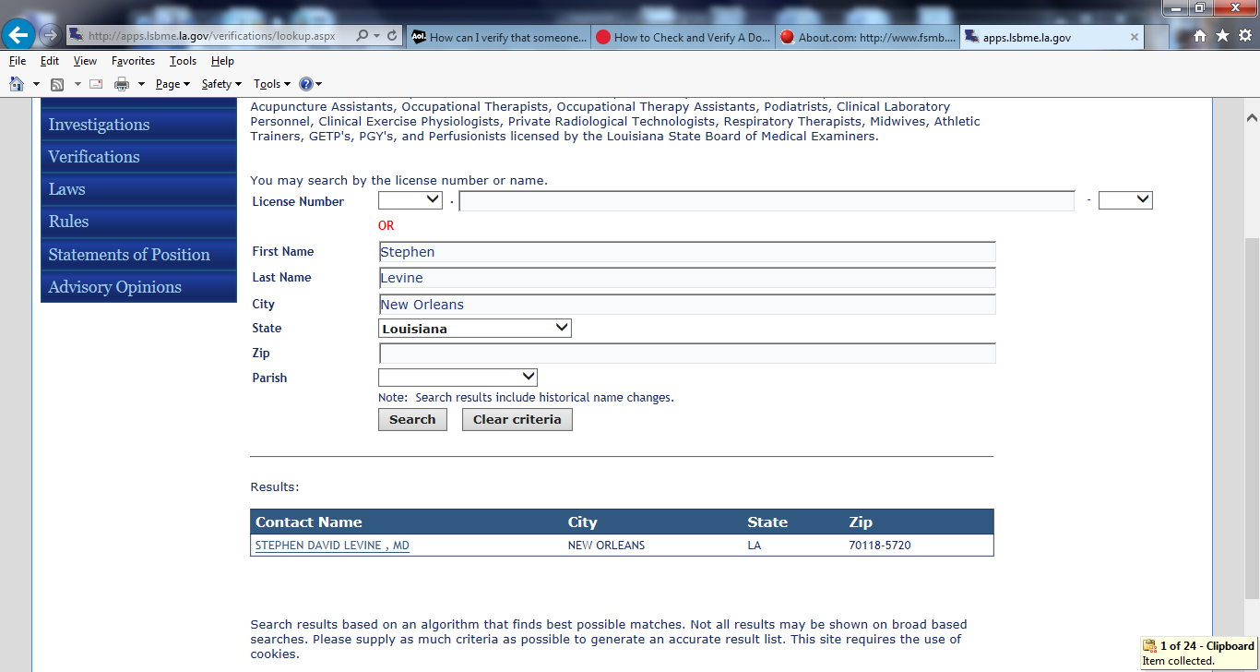

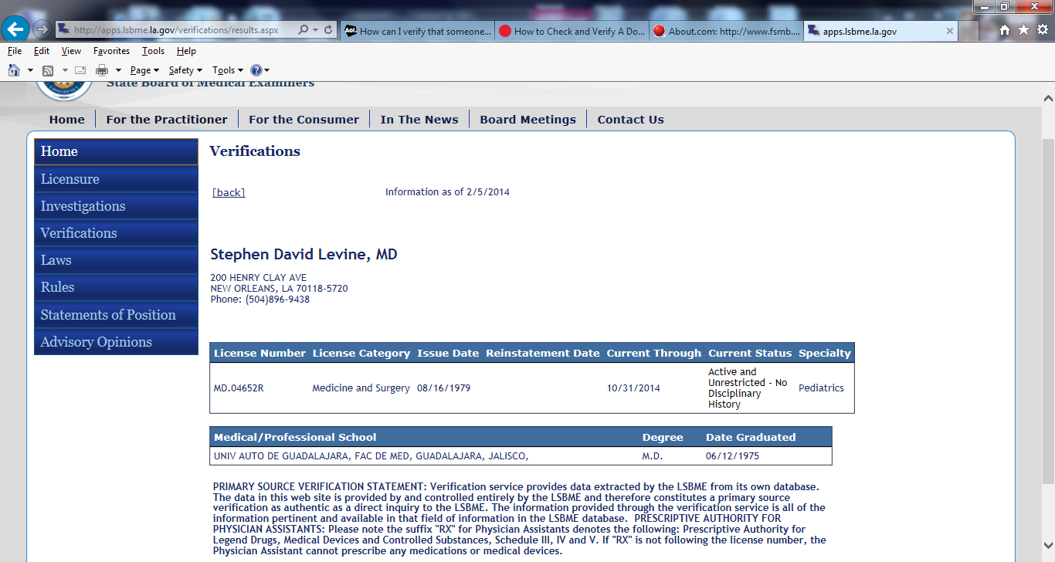

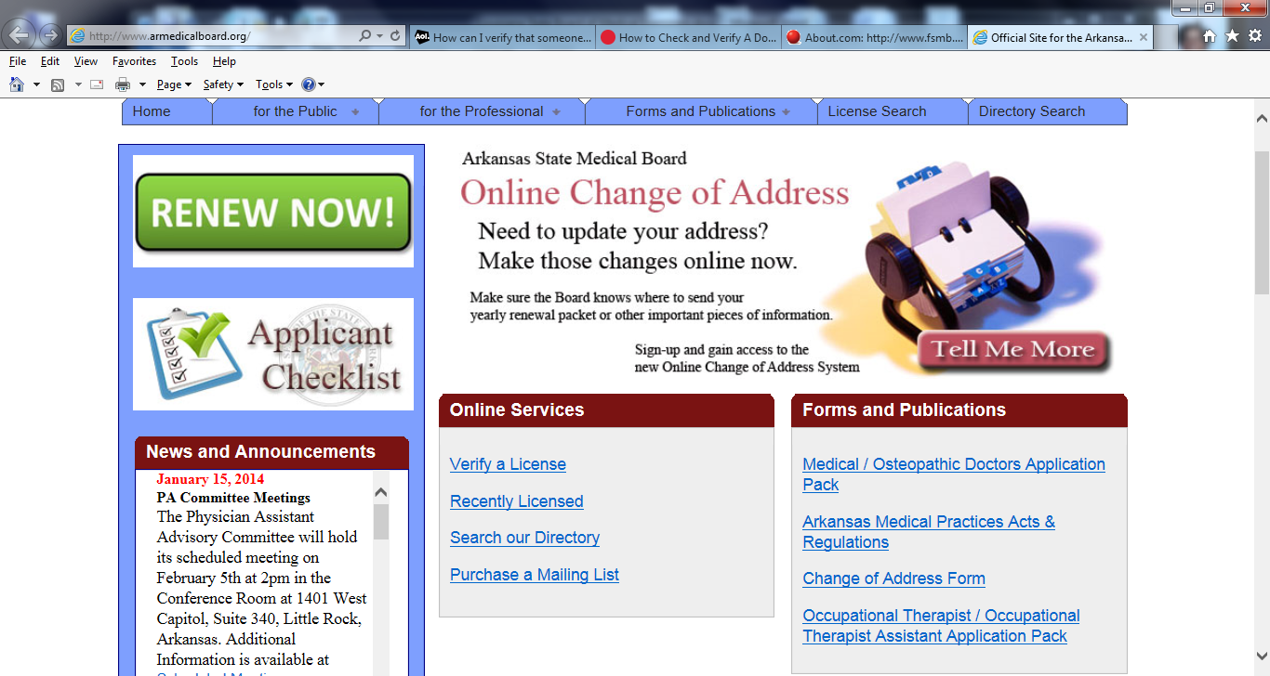

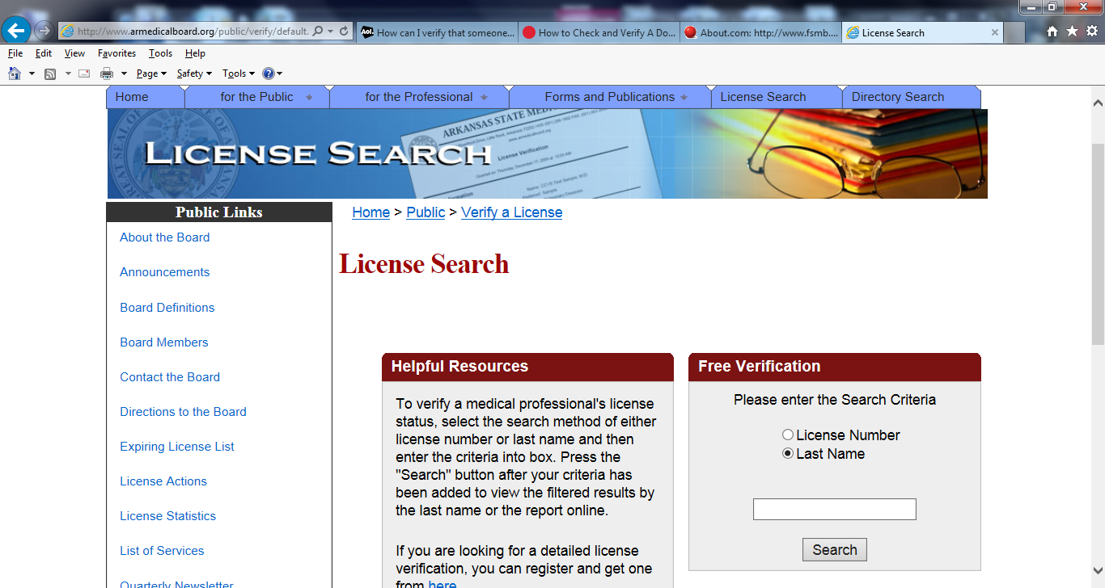

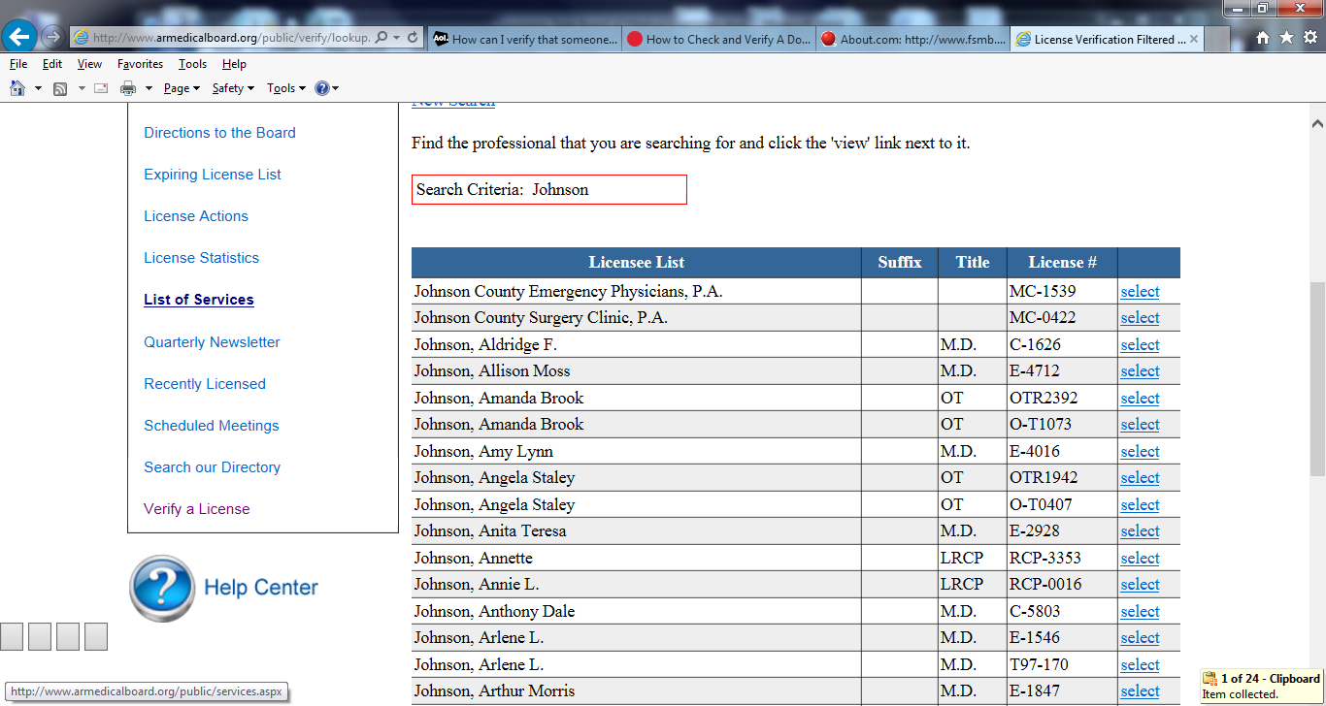

http://patients.about.com/gi/o.htm?zi=1/XJ&zTi=1&sdn=patients&cdn=health&tm=63&f=10&su=p284.13.342.ip_&tt=2&bt=6&bts=6&zu=http%3A//www.fsmb.org/directory_smb.html

FEDERATION OF STATE MEDICAL BOARDS (FSMB)
Directory of State Medical and Osteopathic Boards
A-B C-D E-F G-H I-J K-L M N O P-S T-U V W-Z
Alabama State Board of Medical Examiners  Larry D. Dixon, Executive Director  P.O. Box 946  Montgomery, AL 36101-0946  (street address: 848 Washington Ave.)  (334) 242-4116 / Fax:(334) 242-4155  (800) 227-2606  www.albme.org | Alaska State Medical Board  Debora J. Stovern, Executive Administrator  550 West Seventh Ave., Suite 1500  Anchorage, AK 99501  (907) 269-8163 / Fax:(907) 269-8196  http://www.commerce.state.ak.us/occ/  pmed.htm | Arizona Medical Board  Patricia McSorley, Interim Executive Director  9545 East Doubletree Ranch Road  Scottsdale, AZ 85258-5514  (480) 551-2700 / Fax: (480) 551-2704  Toll Free: (877) 255-2212  www.azmd.gov
Arizona Board of Osteopathic Examiners in Medicine and Surgery  Jenna Jones, Executive Director  9535 East Doubletree Ranch Road  Scottsdale, AZ 85258-5539  (480) 657-7703 / Fax (480) 657-7715  www.azdo.gov | Arkansas State Medical Board  Peggy Pryor Cryer, Executive Secretary  1401 West Capitol Avenue, Suite 340  Little Rock, AR 72201  (501) 296-1802 / Fax:(501) 603-3555  www.armedicalboard.org
Medical Board of California  Kimberly Kirchmeyer, Interim Executive Director  2005 Evergreen Street, Suite 1200  Sacramento, CA 95815  (916) 263-2389 / Fax:(916) 263-2387  (800) 633-2322  www.mbc.ca.gov | Osteopathic Medical Board of California  Angie Burton, Executive Director  1300 National Drive, Suite 150  Sacramento, CA 95834  (916) 928-8390 / Fax:(916) 928-8392  www.ombc.ca.gov/ | Colorado Medical Board  Karen M. McGovern, JD, Program Director  1560 Broadway, Suite 1300  Denver, CO 80202-5140  (303) 894-7690 / Fax:(303) 894-7692  www.dora.state.co.us/medical
Connecticut Medical Examining Board  Jeff Kardys, Board Liaison  P.O. Box 340308  Hartford, CT 06134-0308  (street address 410 Capitol Ave., MS #13PHO)  Licensing/Examinations, (860) 509-8374  Administrative (860) 509-7648 / Fax:(860) 509-7553  Complaints: (860) 509-7552 / Complaint Toll Free: (800) 842-0038  www.dph.state.ct.us | Delaware Board of Medical Licensure and Discipline  Gayle L. MacAfee, MS, Executive Director  861 Silver Lake Blvd., Suite 203,  Cannon Building  Dover, DE 19904  (302) 739-4522 / Fax:(302) 739-2711  www.dpr.delaware.gov | District of Columbia Board of Medicine  Jacqueline A. Watson, DO, MBA, Executive Director  899 North Capitol St. NE, 1st Flr.  Washington D.C. 20002  (202) 724-8800/Fax: (202) 724-8677  http://doh.dc.gov/bomed
Back to Top
Florida Board of Medicine  Allison Dudley, Esq., Executive Director  Department of Health  4052 Bald Cypress Way, BIN #C03  Tallahassee, FL 32399-3253  (850) 245-4131/Fax:(850) 488-9325  Complaints Toll Free: (888) 419-3456  http://www.flboardofmedicine.gov/ | Florida Board of Osteopathic Medicine  Anthony Jusevitch, Executive Director  4052 Bald Cypress Way, BIN C06  Tallahassee, FL 32399-1753  (850) 245-4161 / Fax:(850) 487-9874  http://www.doh.state.fl.us/mqa/osteopath/
Georgia Composite Medical Board  LaSharn Hughes, MBA, Executive Director  2 Peachtree Street, NW, 36th Floor  Atlanta, GA 30303  (404) 656-3913 / Fax:(404) 656-9723  www.medicalboard.georgia.gov/ | Guam Board of Medical Examiners  Marlene Carbullido, Acting Administrator  Health Professional Licensing Office  123 Chalan Kareta South Route 10  Mangilao, Guam 96913-6304  (671) 735-7406-8 / Fax:(671) 735-7413 | Hawaii Medical Board  Constance I. Cabral, Executive Officer  Ahlani K. Quiogue, Executive Officer  Department of Commerce and Consumer Affairs  P.O. Box 3469  Honolulu, HI 96813  (street address: 335 Merchant St., Room 301, 96813)  (808) 586-3000 / Fax:(808) 586-2874  http://www.hawaii.gov/dcca/pvl
Idaho State Board of Medicine  Nancy M. Kerr, RN, MEd, Executive Director  1755 Westgate Drive, Suite 140  Boise, ID 83704  (street address: 83704)  (208) 327-7000 / Fax:(208) 327-7005  http://bom.idaho.gov | Illinois Department of Financial and Professional Regulation  Division of Professional Regulation,  Jay Stewart, JD, Executive Director  Chicago Office (disciplinary issues)  Jill Kreoger, Disciplinary Board Liaison  James R. Thompson Center  100 W. Randolph Street, Suite 9-300  Chicago, IL 60601  (312) 814-4500 / Fax:(312) 814-3145  Complaints: (312) 814-6910  www.idfpr.com | Illinois Department of Financial and Professional Regulation  Division of Professional Regulation,  Jay Stewart, JD, Executive Director  Springfield Office (licensure issues)  Kim Scott, Licensure Manager  320 W. Washington St., 3rd Floor  Springfield, IL 62786  (217) 785-0800 / Fax:(217) 782-7645  www.idfpr.com
Medical Licensing Board of Indiana  Michael Minglin, JD, Board Director  402 W. Washington St., Room W064  Indianapolis, IN 46204  (317) 232-2960 / Fax:(317) 233-4236  http://www.in.gov/pla/medical.htm | Iowa Board of Medicine  Mark Bowden, Executive Director  400 SW 8th St., Suite C  Des Moines, IA 50309-4686  (515) 281-5171 / Fax:(515) 242-5908  www.medicalboard.iowa.gov
Back to Top
Kansas Board of Healing Arts  Kathleen J. Selzler Lippert, JD, Executive Director  800 SW Jackson, Lower Level-Suite A  Topeka, KS 66612  (785) 296-7413 / Fax:(785) 296-0852  www.ksbha.org | Kentucky Board of Medical Licensure  Michael Rodman, Executive Director  Hurstbourne Office Park  310 Whittington Parkway, Suite 1B  Louisville, KY 40222-4916  (502) 429-7150 / Fax:(502) 429-7158  kbml.ky.gov | Louisiana State Board of Medical Examiners  Cecilia A. Mouton, MD, Executive Director  P.O. Box 30250  New Orleans, LA 70190-0250  (street address: 630 Camp St., 70130)  (504) 568-6816 / Fax:(504) 568-5754  www.lsbme.louisiana.gov
Maine Board of Licensure in Medicine  Randal C. Manning, MBA, CMBE, Executive Director  137 State House Station (U.S. mail)  161 Capitol Street (delivery service)  Augusta, ME 04333  (207) 287-3601 / Fax:(207) 287-6590  www.maine.gov/md | Maine Board of Osteopathic Licensure  Susan E. Strout, Executive Secretary  142 State House Station  Augusta, ME 04333-0142  (207) 287-2480 (207) 287-3015  http://www.maine.gov/osteo/ | Maryland Board of Physicians  Christine A. Farrelly, Acting Executive Director  P.O. Box 2571  Baltimore, MD 21215-0095  (street address: 4201 Patterson Ave., fourth floor, 21215)  (410) 764-4771 / Fax:(410) 358-1298  (800) 492-6836  www.mbp.state.md.us/
Massachusetts Board of Registration in Medicine  Barbara A. Piselli, JD, Interim Executive Director  200 Harvard Mill Square, Suite 330,  Wakefield, MA 01880  (781) 876-8200  (800) 377-0550  www.massmedboard.org | Michigan Board of Medicine  Carole Engle, Director  P.O. Box 30670  Lansing, MI 48909-8170  (street address: 611 W. Ottawa St, 1st floor, 48933)  (517) 335-0918 / Fax:(517) 373-2179  www.michigan.gov/healthlicense | Michigan Board of Osteopathic Medicine and Surgery  Joseph E. Campbell, Regulatory Division Director  P.O. Box 30670  Lansing, MI 48909-8170  (street address: 611 W. Ottawa St, 1st floor, 48933)  (517) 335-0918 / Fax:(517) 373-2179  www.michigan.gov/healthlicense
Minnesota Board of Medical Practice  Robert A. Leach, JD, Executive Director  University Park Plaza  2829 University Ave. SE, Suite 500  Minneapolis, MN 55414-3246  (612) 617-2130 / Fax:(612) 617-2166  Hearing impaired 1-800-627-3529  www.bmp.state.mn.us | Mississippi State Board of Medical Licensure  H. Vann Craig, MD, Executive Director  1867 Crane Ridge Drive, Suite 200B  Jackson, MS 39216  (601) 987-3079 / Fax:(601) 987-4159  www.msbml.state.ms.us | Missouri State Board of Registration for the Healing Arts  Connie Clarkston, Executive Director  3605 Missouri Blvd.  Jefferson City, MO 65109  (street address: 3605 Missouri Blvd., 65109)  (573) 751-0098 / Fax:(573) 751-3166  www.pr.mo.gov/healingarts.asp
Back to Top
Montana Board of Medical Examiners
Ian Marquand, Executive Director
P.O. Box 200513
Helena, MT 59620-0513
(406) 841-2360 / Fax: (406) 841-2305
Discovering Montana
Nebraska Board of Medicine and Surgery  Becky Wisell, Administrator  Health and Human Services  Regulation and Licensure Credentialing Division  Becky Wisell, Section Administrator  P.O. Box 94986  Lincoln, NE 68509-4986  (402) 471-2118 / Fax:(402) 471-3577  dhhs.ne.gov/Pages/default.aspx | Nevada State Board of Medical Examiners  Douglas C. Cooper, CMBI, Executive Director  1105 Terminal Way, Suite 301  Reno, NV 89502-2144  (775) 688-2559 / Fax:(775) 688-2321  www.medboard.nv.gov | Nevada State Board of Osteopathic Medicine  Barbara E. Longo, Executive Director  901 American Pacific Dr., Unit 180  Henderson, NV 89014  (702) 732-2147 / Fax:(702) 732-2079  www.bom.nv.gov
New Hampshire State Board of Medicine  Kathryn M. Bradley, JD, Executive Director  121 South Fruit Street  Concord, NH 03301-2412  (603) 271-1203 / Fax:(603) 271-6702  complaints (800) 780-4757  www.nh.gov/medicine | New Jersey State Board of Medical Examiners  William V. Roeder, JD, Executive Director  P.O. Box 183  Trenton, NJ 08625-0183  (609) 826-7100 / Fax:(609) 826-7117  www.state.nj.us/lps/ca/medical.htm#bme5 | New Mexico Medical Board  Lynn S. Hart, Executive Director  P.O. Box 25101  Santa Fe, NM 87505  (505) 476-7220 / Fax:(505) 476-7237  www.nmmb.state.nm.us
New Mexico Board of Osteopathic Medical Examiners  Martha L. Gallegos, Board Administrator  2550 Cerrillos Road  Santa Fe, NM 87501-5101  (505) 476-4654 / Fax:(505) 476-4645  http://www.rld.state.nm.us/boards/  Osteopathy.aspx | New York State Board for Medicine (Licensure)  Suzanne M. Sullivan, Acting Executive Secretary  89 Washington Avenue, 2nd Floor, West Wing  Albany, NY 12234  (518) 474-3817 Ext. 560 / Fax:(518) 474-3706  www.op.nysed.gov | New York State Board for Professional Medical Conduct (Discipline)  Keith W. Servis, Executive Director  Riverview Center  150 Broadway Suite 355  Albany, NY 12204  (518) 402-0855 / Fax:(518) 402-0866  www.health.state.ny.us/
North Carolina Medical Board  R. David Henderson, JD, Executive Director  P.O. Box 20007  Raleigh, NC 27619  (919) 326-1100 / Fax:(919) 326-1130  www.ncmedboard.org | North Dakota State Board of Medical Examiners  Duane Houdek, JD, Executive Secretary/Treasurer  City Center Plaza  418 E. Broadway, Suite 12  Bismarck, ND 58501  (701) 328-6500 / Fax:(701) 328-6505  www.ndbomex.com | Northern Mariana Islands  Florence C. Sablan, Executive Director  Health Care Professions Licensing Board  Phonpei Court  Building 1242  Capitol Hill, Saipan, MP 96950  (670) 664-4809 / Fax:(670) 664-4814  www.cnmiguide.com
Back to Top
State Medical Board of Ohio  Aaron E. Haslam, Executive Director  30 E. Broad St. 3rd Floor  Columbus, OH 43215-6127  (614) 466-3934 / Fax:(614) 728-5946  (800) 554-7717  www.med.ohio.gov | Oklahoma State Board of Medical Licensure and Supervision  Lyle R. Kelsey, MBA, CMBE, Executive Director  P.O. Box 18256  Oklahoma City, OK 73154-0256  (405) 962-1400 / Fax:(405) 962-1499  (800) 381-4519  www.okmedicalboard.org | Oklahoma State Board of Osteopathic Examiners  Deborah J. Bruce, JD, Executive Director  4848 N. Lincoln Blvd., Suite 100  Oklahoma City, OK 73105-3335  (405) 528-8625 / Fax:(405) 557-0653  www.ok.gov/osboe/
Oregon Medical Board
Kathleen Haley, JD, Executive Director
1500 SW 1st Ave., Suite 620
Portland, OR 97201-5847
(971) 673-2700 / Fax:(971) 673-2670
www.oregon.gov/OMB
Pennsylvania State Board of Medicine  Michael Coates, Administrator  P.O. Box 2649  Harrisburg, PA 17105-2649  (717) 787-2381 / Fax:(717) 787-7769  pennsylvania state board | Pennsylvania State Board of Osteopathic Medicine  Suzanne Smith, Administrator  P.O. Box 2649  Harrisburg, PA 17105-2649  (street address: 124 Pine St., 17101)  (717) 783-4858 / Fax:(717) 787-7769  www.dos.state.pa.us | Puerto Rico Board of Medical Licensure and Discipline  Gladys N. Torres Díaz, Esq., Executive Director  Edificio GM Group  Plaza Frente al Antiguo Edificio de la Electrónica  Ave. Ponce de León 1590- Tercer Piso  Rio Piedras, PR 00926  (787) 999-8989 Ext. 6592
Rhode Island Board of Medical Licensure and Discipline  James V. McDonald, MD, MPH, Chief Administrative Officer  Department of Health  Cannon Building, Room 205  Three Capitol Hill  Providence, RI 02908-5097  (401) 222-3855 / Fax:(401) 222-2158  http://www.health.ri.gov/hsr/bmld/ | South Carolina Board of Medical Examiners  Department of Labor, Licensing and Regulation  Rion Alvey, Interim Director  110 Centerview Drive, Suite 202  Columbia, SC 29210-1289  (803) 896-4500 / Fax:(803) 896-4515  www.llr.state.sc.us/pol/medical | South Dakota Board of Medical and Osteopathic Examiners  Margaret B. Hansen, PA-C, CMBE, Executive Director  101 N. Main Avenue, Suite 301  Sioux Falls, SD 57104  (605) 367-7781 / Fax:(605) 367-7786  www.sdbmoe.gov
Tennessee Board of Medical Examiners  Rosemarie A. Otto, Executive Director  665 Mainstream Drive  Nashville, TN 37243  (800) 778-4123 / Fax:(615) 253-4484  http://health.state.tn.us | Tennessee Board of Osteopathic Examination  Rosemarie A. Otto, Interim Executive Director  665 Mainstream Drive  Nashville, TN 37243  (800) 778-4123 / Fax:(615) 253-4484  http://health.state.tn.us | Texas Medical Board  Mari Robinson, JD, Executive Director  P.O. Box 2018  Austin, TX 78768-2018  (512) 305-7010/Fax: (512) 305-7008  Disciplinary Hotline (800) 248-4062  Consumer Complaint Hotline (800) 201-9353  www.tmb.state.tx.us
Back to Top
Utah Department of Commerce  Division of Occupational and Professional Licensure  Physicians Licensing Board  Noel Taxin, MS, Bureau Manager  PO Box 146741  Salt Lake City, UT 84114-6741  (801) 530-6628 / Fax:(801) 530-6511  www.dopl.utah.gov | Utah Osteopathic Physicians & Surgeons Licensing Board  Division of Occupational and Professional Licensure  Physicians Licensing Board  Noel Taxin, MS, Bureau Manager  PO Box 146741  Salt Lake City, UT 84114-6741  (801) 530-6628 / Fax:(801) 530-6511  www.dopl.utah.gov
Vermont Board of Medical Practice  David K. Herlihy, JD, Executive Director  108 Cherry Street  Burlington, VT 05401  (802) 657-4220 / Fax:(802) 657-4227  www.healthvermont.gov | Vermont Board of Osteopathic Physicians and Surgeons  Ronald Klein, RPh, Executive Director  Office of Professional Regulation  89 Main Street, 3rd Floor  Montpelier, VT 05620-3402  802-828-1134  www.vtprofessionals.org | Virgin Islands Board of Medical Examiners  Deborah Richardson-Peter, MPA, Interim Director  Department of Health  48 Sugar Estate  St. Thomas, VI 00802  (340) 774-0117/ Fax:(340) 777-4001  Medical Licensure Requirements
Virginia Board of Medicine
William L. Harp, MD, Executive Director
Perimeter Center
9960 Mayland Drive, Suite 300
Henrico, VA 23233-1463
Phone:(804) 367-4600
Fax Licensing Unit:(804) 527-4426 , Fax Discipline Unit:(804) 527-4429
www.dhp.virginia.gov
Washington State Medical Quality Assurance Commission  Maryella E. Jansen, Executive Director  Department of Health  PO Box 47866  Olympia, WA 98504-7866  (360) 236-2750 / Fax:(360) 236-2795  http://www.doh.wa.gov | Washington State Board of Osteopathic Medicine and Surgery  Blake T. Maresh, MPA, Executive Director  Department of Health  P.O. Box 47852  Olympia, WA 98504-7852  (360) 236-4700 / Fax:(360) 236-4818  www.doh.wa.gov | West Virginia Board of Medicine  Robert C. Knittle, MS, Executive Director  101 Dee Drive, Suite 103  Charleston, WV 25311  (304) 558-2921 / Fax:(304) 558-2084  www.wvbom.wv.gov
West Virginia Board of Osteopathic Medicine  Diana K. Shepard, Executive Director  405 Capitol Street, Suite 402  Charleston, WV 25301  (304) 558-6095 / Fax:(304) 558-6096  www.wvbdosteo.org | State of Wisconsin  Department of Safety and Professional Services  Department of Regulation and Licensing  Tom H. Ryan, JD, MPA, Bureau Director  1400 E. Washington Ave.  Madison, WI 53703  (608) 266-2112 / Fax:(608) 261-7083  Complaints Toll Free: (877) 617-1565  http://dsps.wi.gov | Wyoming Board of Medicine  Kevin D. Bohnenblust, JD, Executive Director  130 Hobbs Avenue, Suite A  Cheyenne, WY 82002  (307) 778-7053 / Fax:(307) 778-2069  Complaint Toll Free: (877) 617-1565  wyomedboard.state.wy.us

